HOTEL RESERVATION MANAGEMENT SYSTEM
Introduction:
The Hotel Reservation System is designed to simplify the booking and room management process in hotels by storing and managing data using SQL. It provides hotel staff with efficient access to information such as room availability, customer details, booking records, payments, and occupancy levels.
This system allows the hotel to make informed decisions, improve customer service, and maintain smooth operational workflow.

Objectives of the System:
- To maintain a database of hotel rooms, reservations, guests, payments, and staff.
- To track room availability and occupancy in real time.
- To generate useful analytical reports such as revenue, bookings, cancellations, and guest trends.
- To reduce manual errors and speed up the reservation process.
- To help management understand business performance and customer behavior.
System Overview:
The system consists of several interconnected tables that handle different aspects of hotel operations:
Tables Used:
- Rooms – Stores details like room number, room type, capacity, price, and status.
- Guests – Contains guest personal information.
- Reservations – Stores booking details including check-in, check-out, room type, amount, and status.
- Payments – Records payment method, date, and amount.
- Staff / Check-ins – Stores information about staff handling check-ins, check-outs, and guest services.

- Problem Statement and Queries:

Problem Statement 1:
Management wants to know the total number of rooms registered in the system.

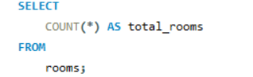

Output:

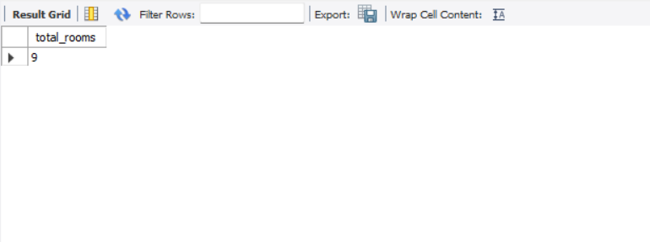

Problem Statement 2:
Show how many rooms are available and how many are booked.

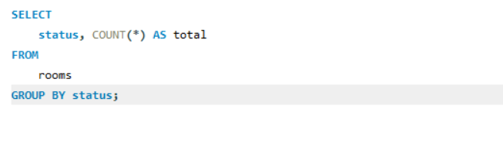

Output:

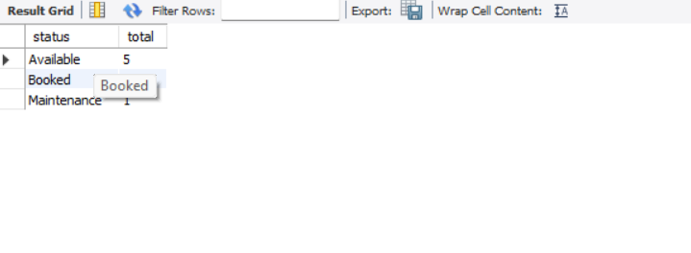

Problem Statement 3:
Find total guests who have made at least one booking.

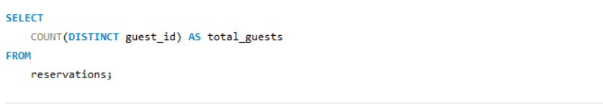

Output:

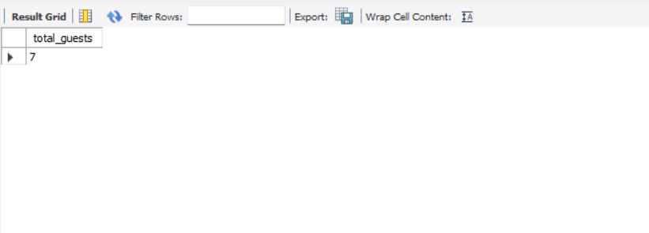

Problem Statement 4:
Show how many bookings exist for each room type.

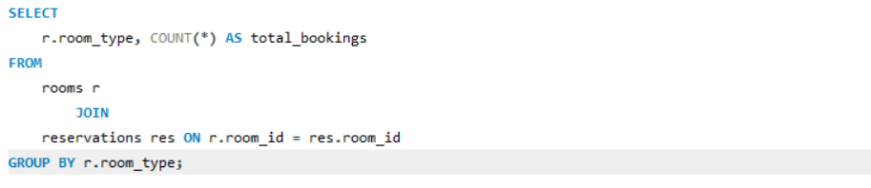

Output:

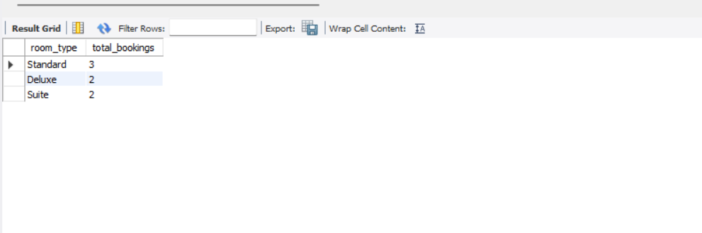

Problem Statement 5:
Calculate revenue generated by each room type.

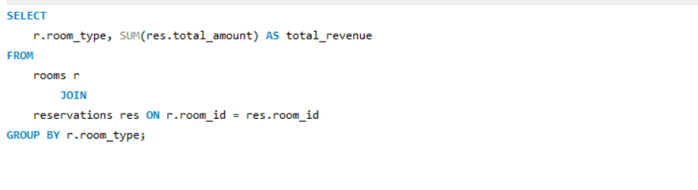

Output:

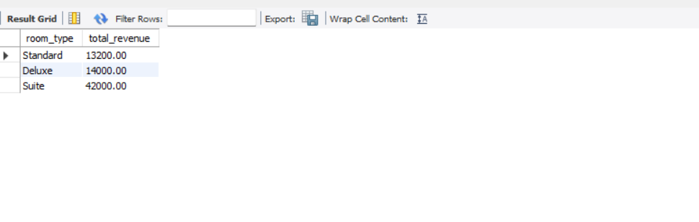

Problem Statement 6:
Show reservations active today.

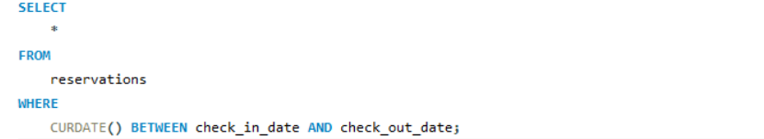

Output:

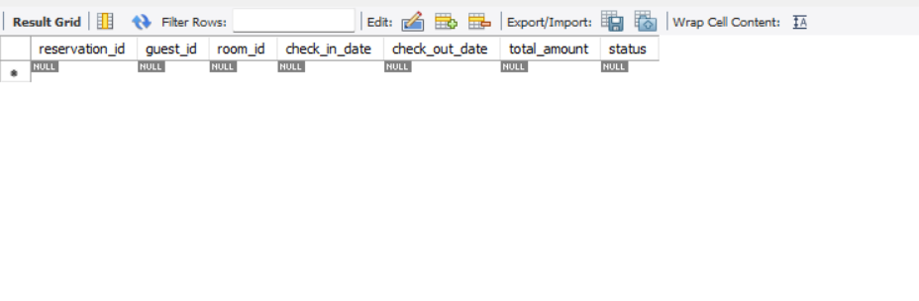

Problem Statement 7:
Show guests who booked more than 3 stays.
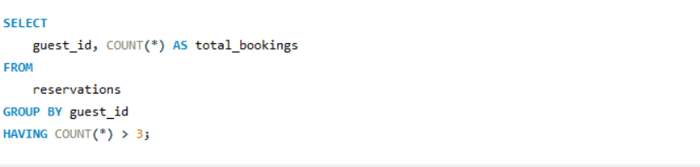
Output:
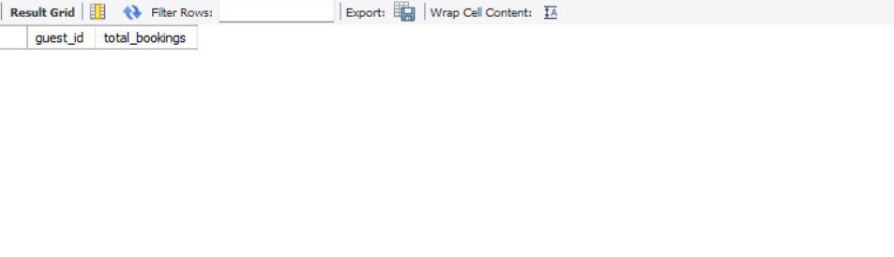

Problem Statement 8:
List guests scheduled to check in tomorrow.
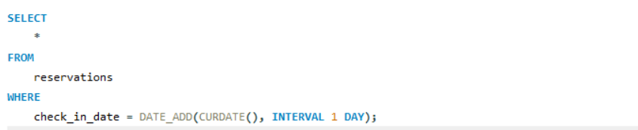

Output:
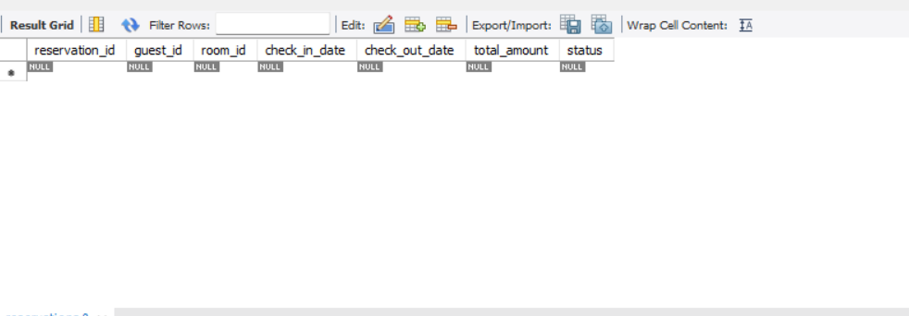

Problem Statement 9:
Show all guests checking out today.
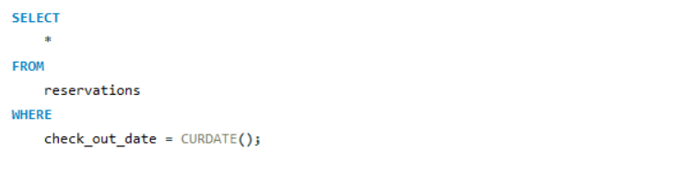
Output:
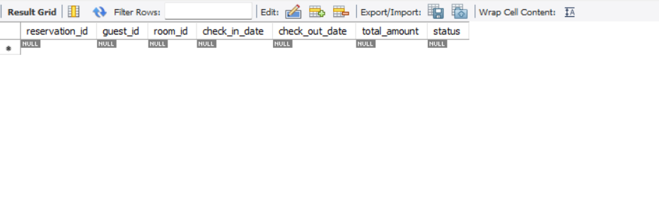

Problem Statement 10:
Total revenue for a specific month.
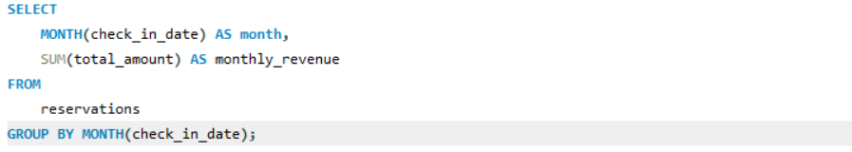
Output:

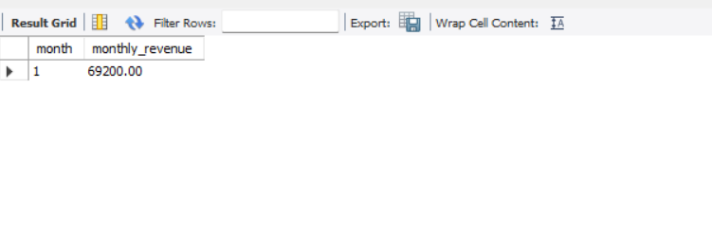

Problem Statement 11:
Find which staff member handled the maximum check-ins.
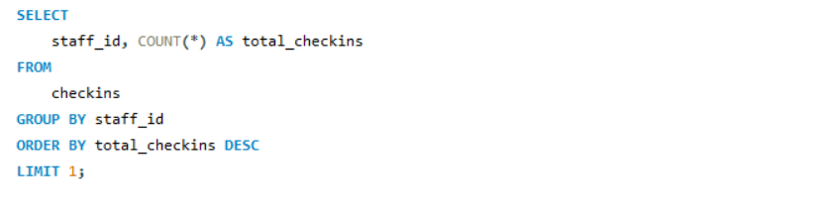
Output:
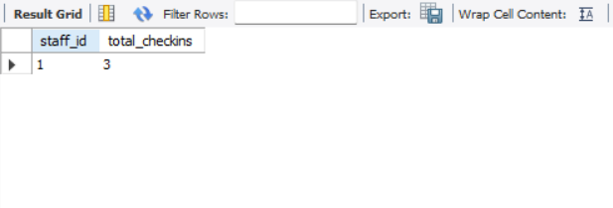

Problem Statement 12:
Calculate occupancy rate: rooms booked / total rooms * 100.
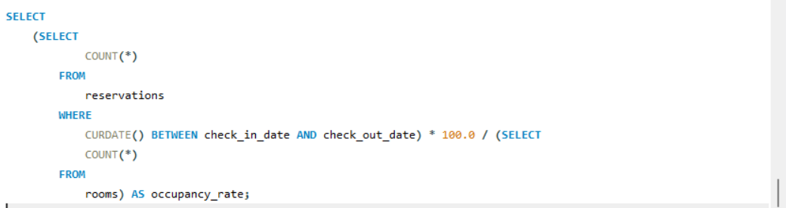
Output:
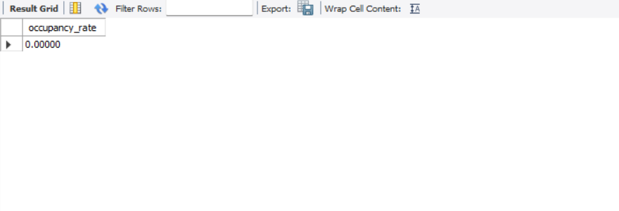

Problem Statement 13:
Show all canceled reservations.
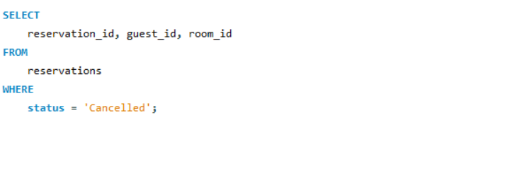
Output:

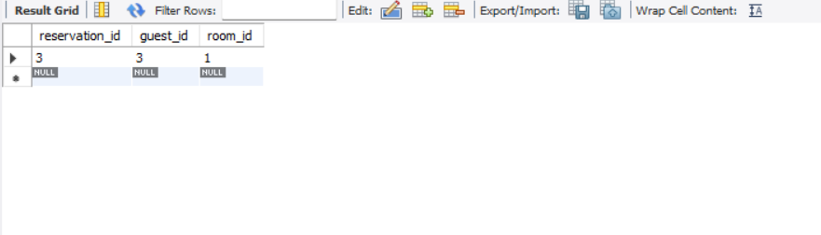

Problem Statement 14:
Compute average number of days guests stay.
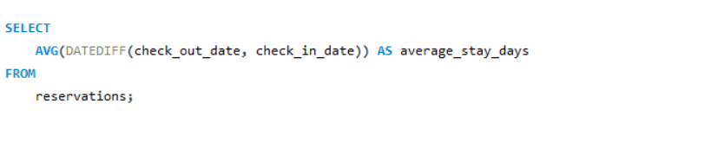
Output:

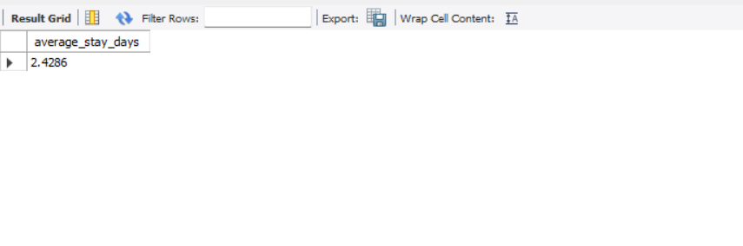

Problem Statement 15:
Show payment methods with count.
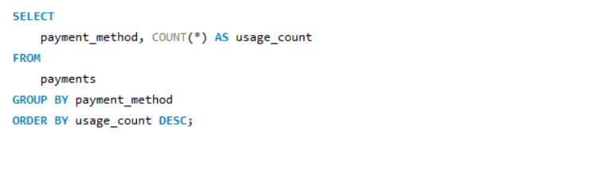

Output:

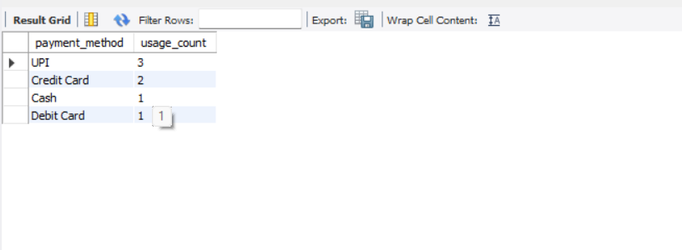

Conclusion:
The Hotel Reservation System provides a structured and efficient way to manage hotel operations through SQL. By using relational database concepts, SQL queries, and analytical reports, the system ensures accurate reservation tracking, better room management, and improved financial monitoring. It enables hotels to deliver better service, reduce operational errors, and make data-driven decisions that enhance both profitability and customer experience.Through the various SQL queries and reports, the project highlights important business insights such as room availability, booking trends, frequent customers, staff performance, and revenue analysis. These insights help hotel management make informed decisions, optimize room allocation, reduce operational errors, and improve customer satisfaction. Overall, the Hotel Reservation System proves that a database-driven approach is essential for modern hotel operations, enabling better decision-making, improved financial management, and a more organized hospitality experience.

